Sprint 8

**Sprint period: 22.01.2024 – 28.01.2024**

**Planned Capacity for next Sprint:**

No sprints left.

**Burn up Chart**

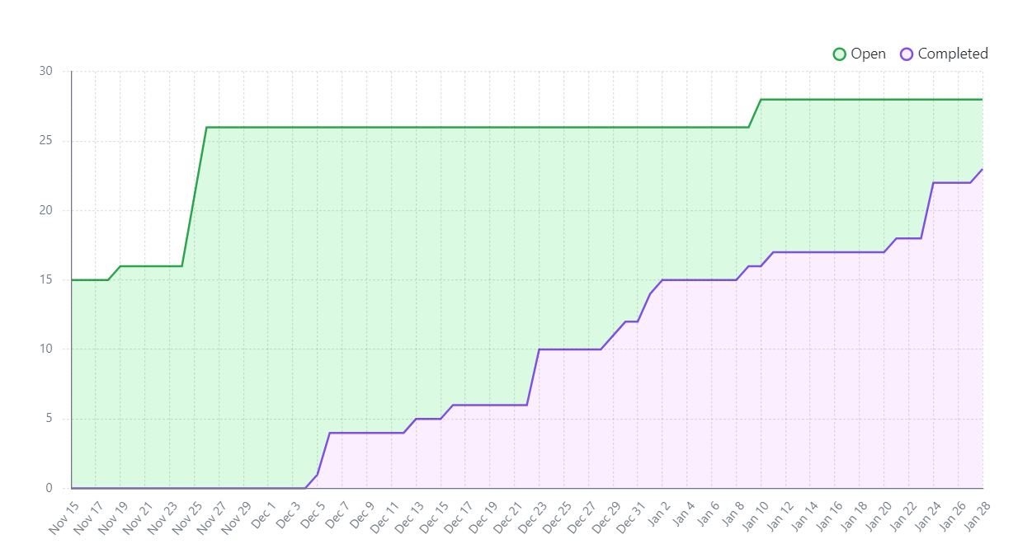

**Sprint Backlog**

* Implement the Level Completed Menu and it’s functionalities – completed
* Improve UI elements for the menus - completed

**Sprint Specific User Stories and Acceptance Criteria**

-As an user I want to have access to a Level Completed Menu that opens up after I finish a level and that allows me to either replay the level or to exit the level so that I can quickly choose what to do after I am done with a level  
Given the user in the game  
When the user finishes the level  
Then a Level Completed Menu should be displayed on the screen that offers the options to replay the level or to exit the level and return to the Select Level Menu

-As an user I want to have access to visually pleasing menus so that my experience is enhanced  
Given the user in the menus  
When the user goes through the menus  
Then the user should see decorated menus that fit the theme of the game

**Sprint Report**

The goal of this sprint was to finish work on the menus and to deliver the final product. The main focus of this sprint was to enhance the aesthetic of the various menus and to fix bugs.

Everything planned for this sprint has been achieved. Furthermore, music has been added to the various scenes of the game. The Software Architecture Report is now in its final form and a document detailing the Testing Paradigms used has been added.

**Retrospective Outcome**

Work on the project has progressed as expected. Improving the UI elements of the menus did not prove to be a challenge, but they have a considerable effect on the overall experience.

**Review Session**

The team is very glad to have worked on such a project and to achieve such results. Everyone worked hard and did their part to contribute to the project.